**Green Campus Clean campus Cell**



**GREEN CAMPUS CLEAN CAMPUS CLUB REPORT 2018-2019**

|  |  |  |
| --- | --- | --- |
| Convener | Smt. Asha Neendur | C:\Users\user\Desktop\Asha miss-Photo.jpg |
| Joint Convener | Dr. Mujeeb Rahiman | C:\Users\user\Desktop\Mujeeb-Photo.jpg |
| Student Co-Ordinator | Mr. Sai Krishnan | C:\Users\user\Desktop\attachments\Saikrishnan.jpg |

The first meeting of the club was held on 22nd September 2018. The meeting was held to select the members of the club.

A campus cleaning was conducted on 5th October 2018 and 18th November 2018. All the departments actively participated in this drive.

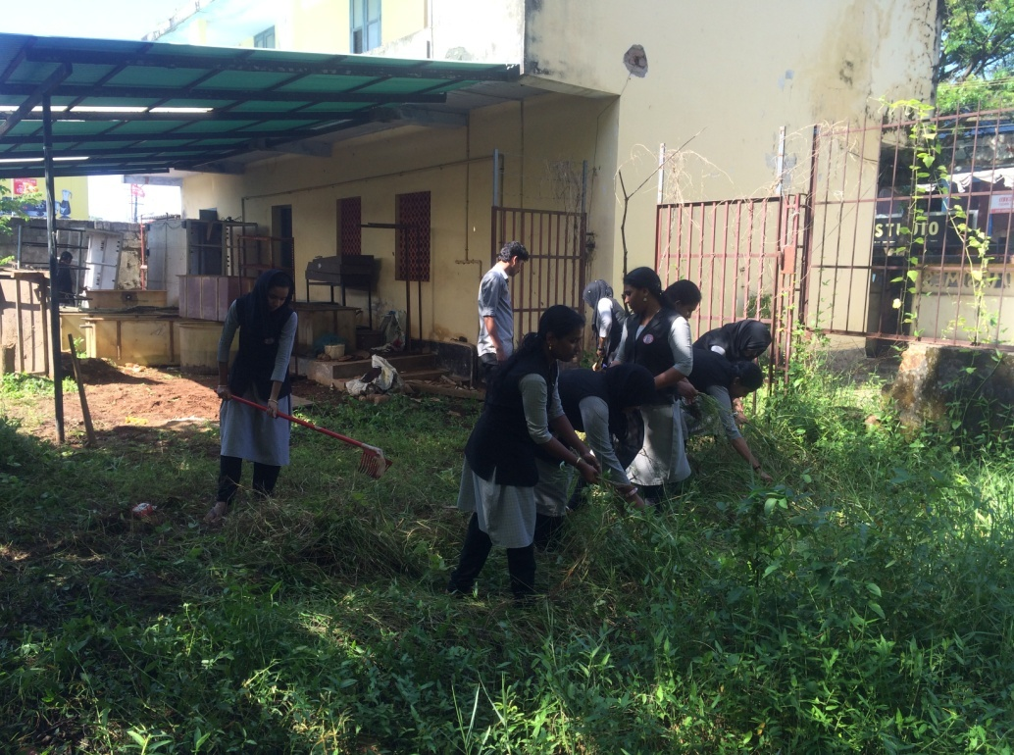

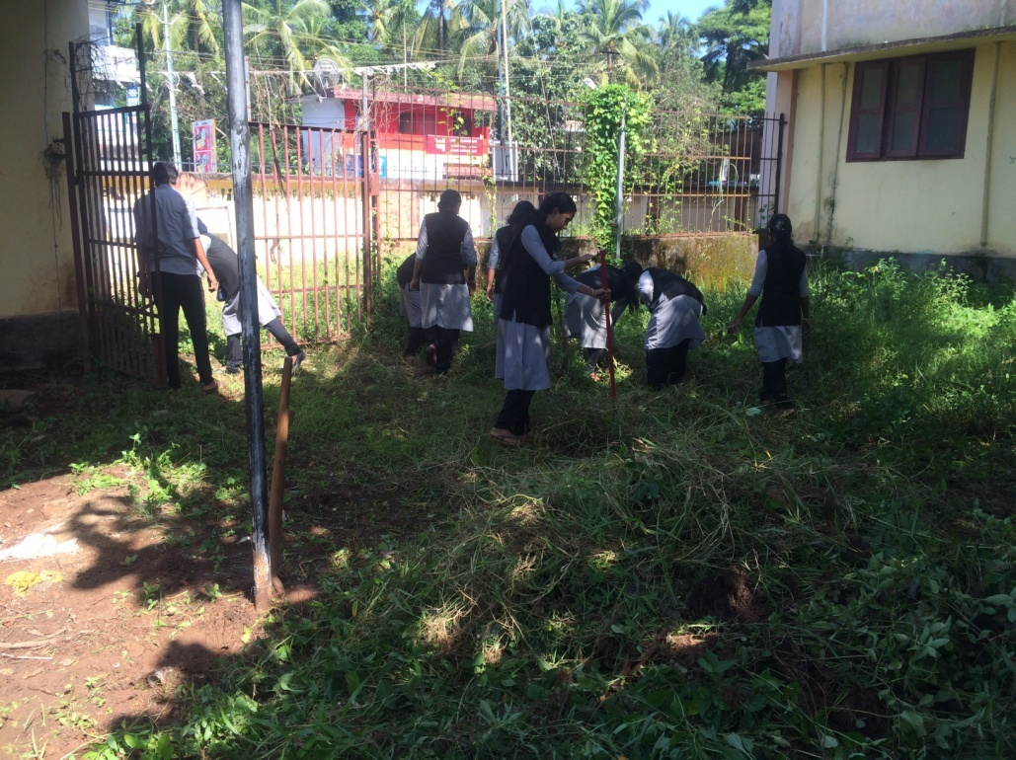

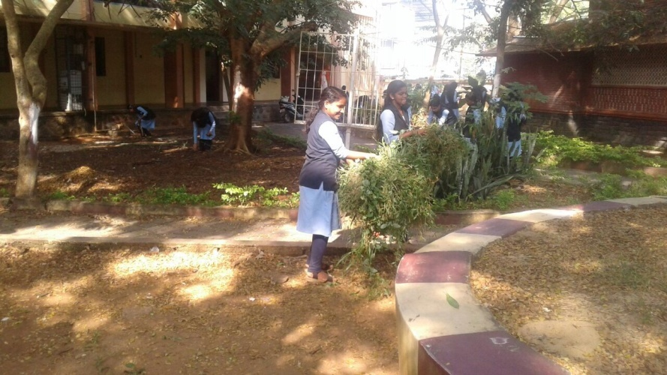

The members of the club regularly planting trees, and cultivated vegetables on green bags.

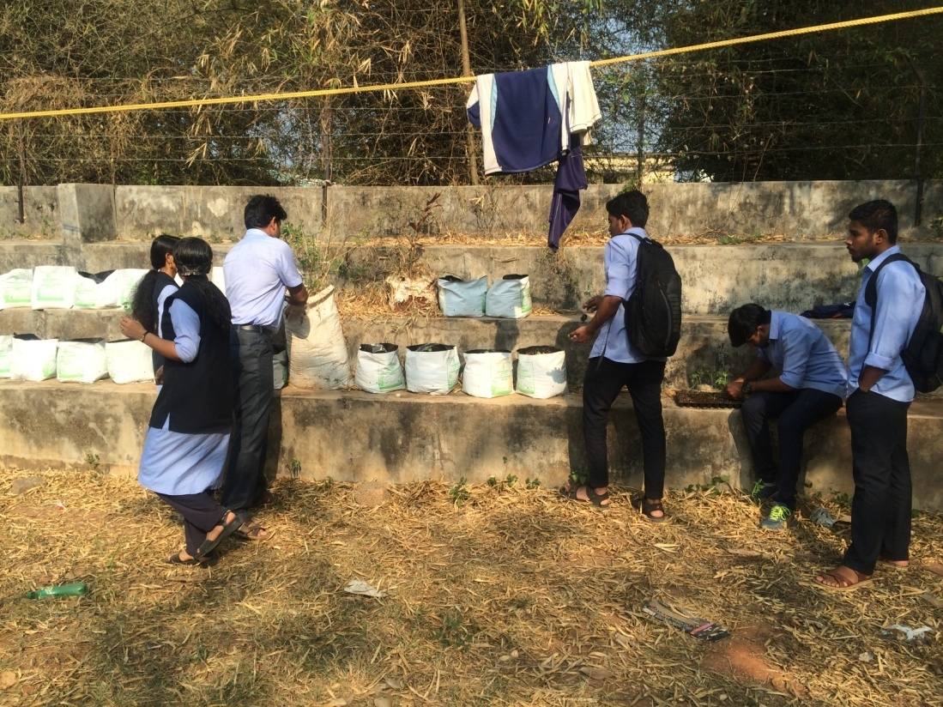

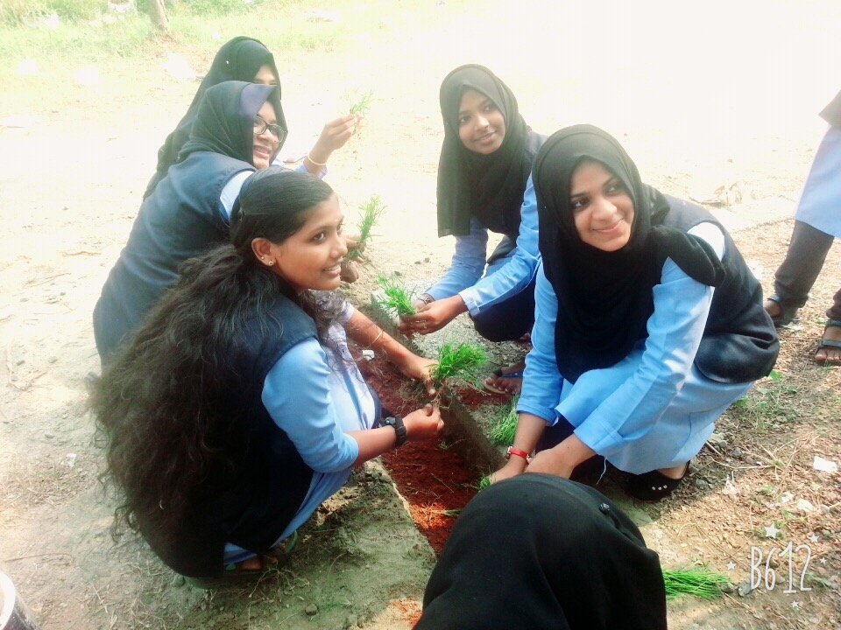

Cultivated vegetables in the campusfrom August 2018 to February 2019 with the participation of clubs and forums of the College

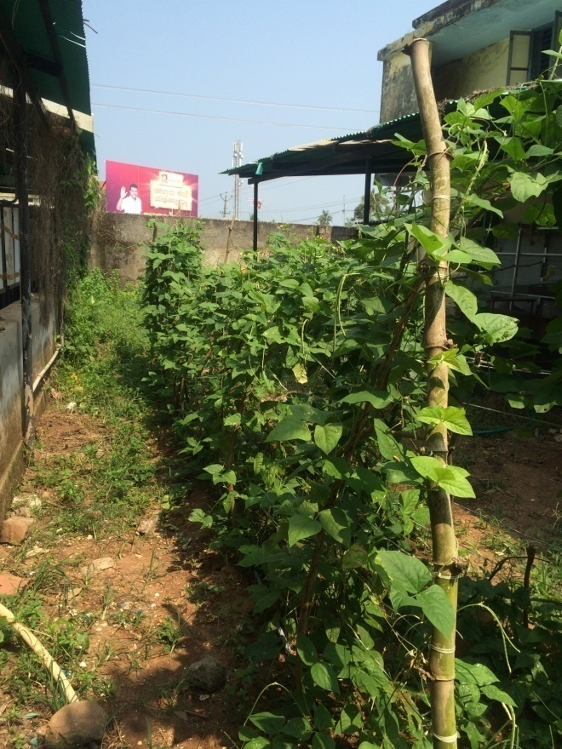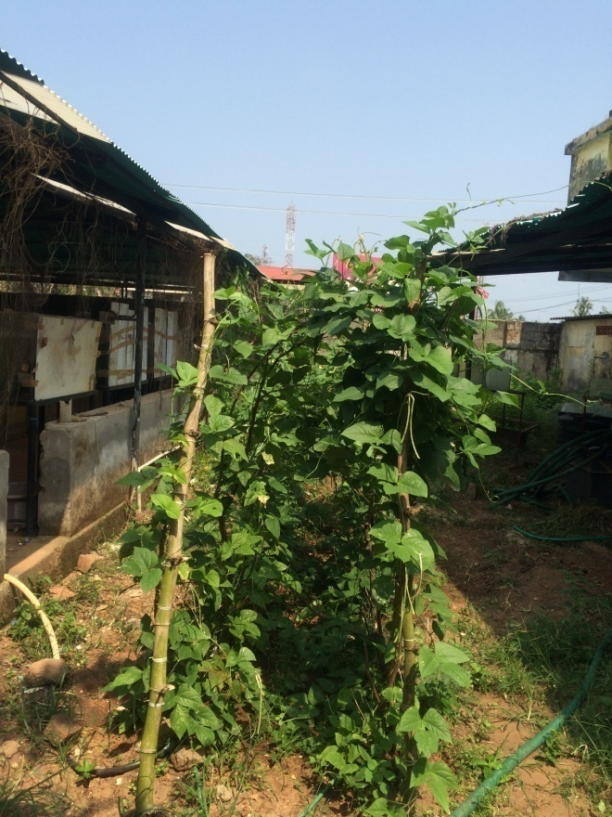

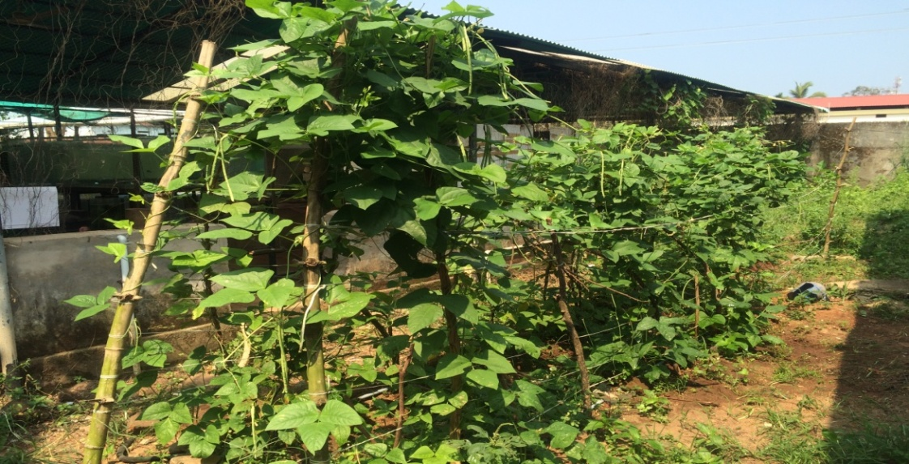

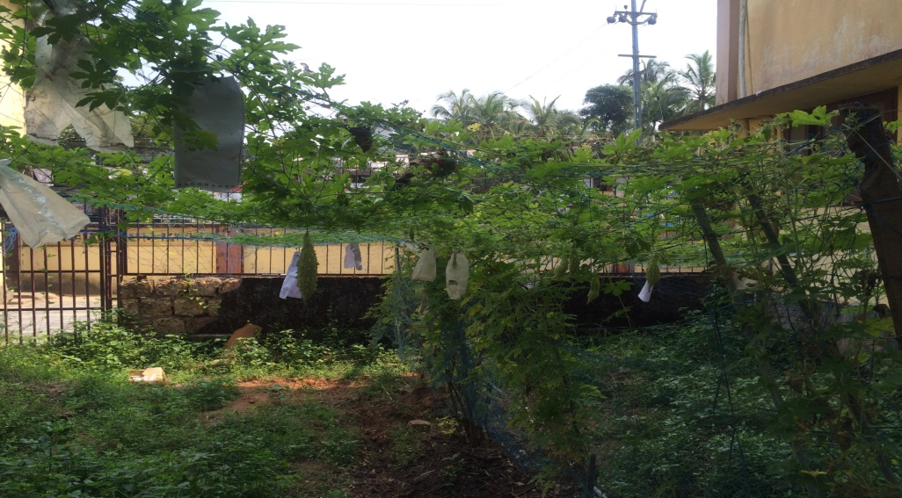

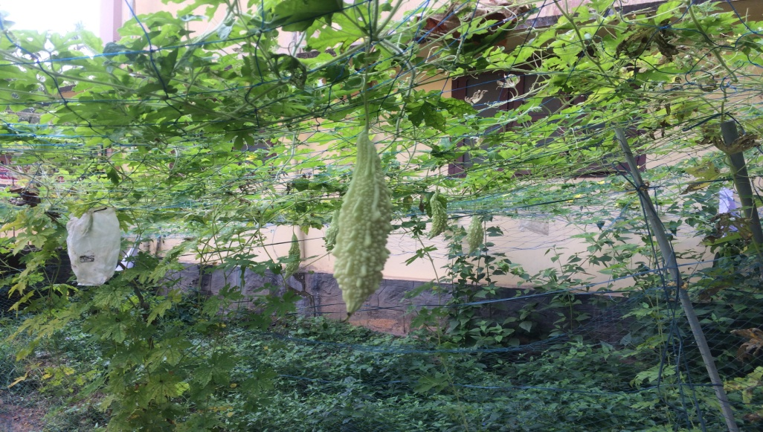

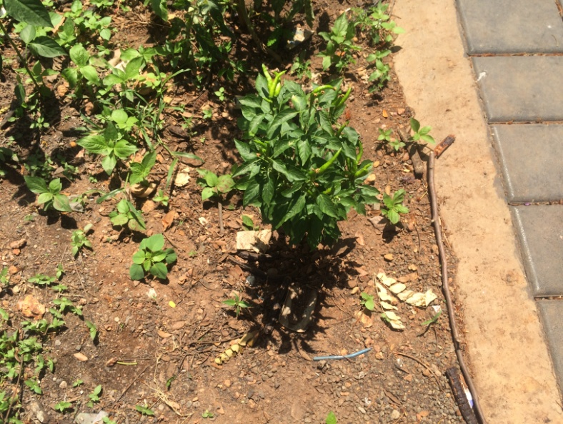

Distributd vegetables saplings to students and workers of the colleges to promote agriculture

